**Chapter 3: Atomic Structure**

**All Lectures Uploaded on YouTube:**

[**https://tinyurl.com/fkm9-chemistry**](https://tinyurl.com/fkm9-chemistry)



**3.1. Introduction to Atomic Models:**

* Scientists developed different atomic models over time.
* These models help us understand **how atoms behave** and **their structure**.
* Every new model improved our knowledge about **atomic structure**.

**Dalton's Atomic Model (1803)**

**John Dalton** (British Chemist) gave the **first scientific theory** of matter called **Dalton’s Atomic Theory**.

**Main Postulates (Important Points):**

* **Matter is made of tiny particles** called **atoms** that **cannot be divided**.
* Atoms of the **same element are identical** in: Mass, Size, Volume
* Atoms **combine**, **separate**, or **rearrange** in **simple ratios** to form compounds during chemical reactions.
* **Atoms cannot be created or destroyed.**

**Importance of Dalton's Model:**

* Explained many chemical laws like: **Law of Multiple Proportions** and **Law of Conservation of Mass**
* Helped in understanding **chemical combinations**.

**Rutherford’s Atomic Model (1911)**

**Ernest Rutherford** performed an experiment to understand the **structure of atom**.

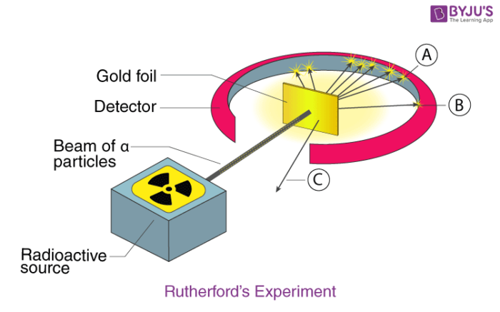

**Rutherford's Experiment:**

* Used **alpha particles** (He²⁺ nuclei) from polonium.
* These were bombarded at a **very thin gold foil** (0.00004 cm thick).
* Expected particles to pass straight through the foil.

**Observations:**

* Most alpha particles **passed through** without deflection.
* A few were **deflected at small angles**.
* Very few were **deflected at large angles (over 90°)**.

**Conclusions from Rutherford's Experiment:**

* **Most of the atom is empty space** (because most particles passed through undeflected).
* **Deflected alpha particles** show there is a **dense, positively charged center** → called the **nucleus**.
* **Alpha particles are not deflected by electrons** because electrons are too small and light.

**Resulting Model – Rutherford's Atomic Model:**

* Called the **planetary model** of atom.
* Electrons **revolve around** the nucleus just like planets revolve around the sun.
* Atom has a **dense nucleus** with **positive charge** (protons).

**Defects in Rutherford’s Model:**

* **Electron Collapse:**  According to classical physics, revolving electrons should **lose energy** and spiral into the nucleus, collapsing the atom.
* **Continuous Spectrum Expected:** Energy loss should emit a **continuous spectrum**, but atoms emit **line spectra** (e.g., hydrogen).

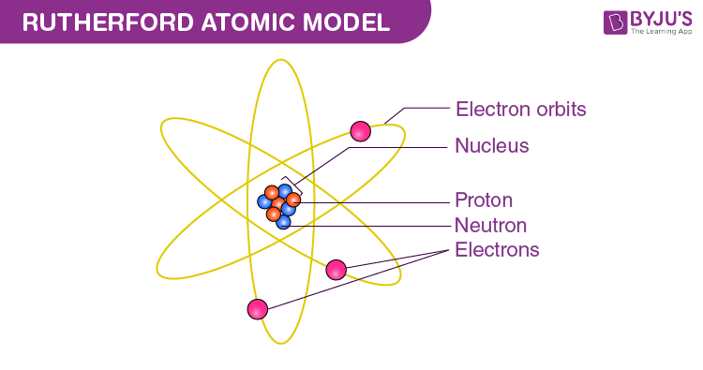

**Bohr’s Atomic Model (1913)**

**Postulates:**

* **Fixed Orbits (Energy Levels):**  Electrons revolve in **specific orbits** with fixed energy (no energy loss).
* **Energy & Distance:**  Farther orbits = Higher energy.
* **Quantized Angular Momentum:**
  + - L = nh\2π

where

* n = orbit number
* h = Planck’s constant = 6.626 x 10⁻³⁴ joule-seconds. (value should not be memorised)
* **Energy Absorption/Emission:**

**Absorption:** Electron jumps to a higher orbit (gains energy).

**Emission:** Electron falls to a lower orbit (releases energy as light).

 Energy difference: ∆E = E2 – E1

* **Line Spectrum Explained:**

Only specific energy transitions → discrete lines (e.g., hydrogen spectrum).

**Limitation:**

Works only for hydrogen-like atoms (single-electron systems).

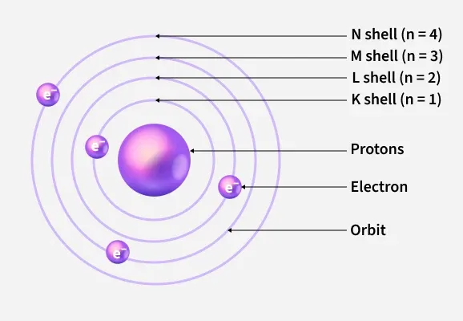

**Quantum Mechanical Model (Modern Atomic Model)**

**Electrons as Dual Nature**

**Louis de Broglie, a French physicist**, in 1924, proposed the dual nature of electrons. He suggested that subatomic particles, like electrons, can exhibit both particle-like and wave-like behaviour. His idea opened the door for new possibilities in understanding the behaviour of sub-atomic particles. This concept made a significant contribution to the development of quantum mechanics.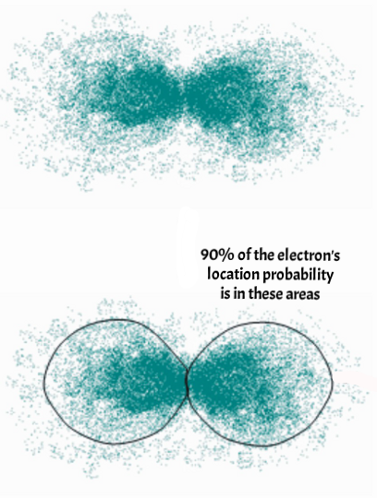

**In 1927, Davisson and Germer** experimentally confirmed the de Broglie hypothesis that an electron has wave-like behaviour. This discovery laid the foundation for modern quantum mechanics.

**Heisenberg’s Uncertainty Principle:**

***It is impossible to simultaneously determine the exact location and future trajectory of an electron. As a result, plotting the electron orbit around the nucleus is quite impossible*.**

**Visualization:**

Think of orbitals as "fuzzy clouds" (not circular orbits).

**Summary Table**

| **Model** | **Key Idea** | **Drawback** |
| --- | --- | --- |
| **Rutherford** | Nucleus + orbiting electrons | Electrons should collapse |
| **Bohr** | Fixed energy levels | Only for H-atom |
| **Quantum** | Orbitals (probability regions) | Complex math, no exact paths |

**Nuclear Force**

Protons repel each other (like charges), yet the nucleus is stable. **Strong Nuclear Force** binds protons and neutrons:

* Stronger than electrostatic repulsion.
* Acts between **proton-proton, neutron-neutron, proton-neutron**.

The nucleus contains protons and neutrons. Protons are positively charged and neutrons are neutral. The nucleus has no negative charge. The positively charged protons must cancel each other out and the nucleus must break apart. But atoms are stable and have existed for billions of years. Therefore, there must be some kind of attraction that connects them. No electrostatic or magnetic forces occur within the core. This is because these forces involve both attraction and repulsion. Therefore, the force that binds protons and neutrons together is a strong force. This force is called a strong nuclear force.

*It is defined as the strong attractive force that binds protons and neutrons together. This force is stronger than electrostatic or magnetic forces. This force exists between neutrons and neutrons, protons and protons, and neutrons and protons*.

**3.2. Subatomic Particles**

Subatomic particles are the fundamental particles that make up atoms.

Protons and neutrons are found in the nucleus of an atom, whereas electrons orbit around the nucleus in energy levels or shells.

| **Particle** | **Charge** | **Mass (amu)** | **Location** |
| --- | --- | --- | --- |
| Proton | +1 | ~1 | Nucleus |
| Neutron | 0 (neutral) | ~1 | Nucleus |
| Electron | -1 | ~1/1836 | Electron shells |

**Behaviour in Electric Fields:**

**Protons:** Deflect toward negative plate.

**Electrons:** Deflect toward positive plate (more sharply due to lower mass).

**Neutrons:** No deflection (neutral).

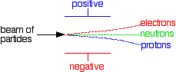

**Why do electrons deflect more than proton?**

In an electric field, electrons and protons experience the same force (F=qE), but electrons are deflected more because they are much lighter (about 1836 times less massive than protons).  
Since

$a=\frac{F}{m}$

the smaller mass gives electrons a much greater acceleration.  
At the same speed, this higher acceleration causes them to change direction more quickly, resulting in greater deflection.

**Charge Neutrality**

Atoms are electrically neutral because the number of protons (positively charged) in the nucleus is equal to the number of electrons (negatively charged) in the electron cloud. The charges balance each other so there is no net charge on the atoms.

Atoms are **neutral** because:

**# Protons = # Electrons** (e.g., Carbon: 6 protons, 6 electrons).

**3.3. Proton or Atomic Number (Z)**

**Atomic Number (Z):**

* Determines the element’s identity (e.g., Z=6 → Carbon).
* Arranges elements in the periodic table.

Each element has It a unique proton number that distinguishes it from other elements. determines the various properties of an element and its position in the periodic table.

**Nucleon number:**

***Nucleon number*** *(mass number) is the total number of* ***protons and neutrons*** *present in the nucleus of an atom. It tells you the mass of the nucleus in atomic mass units.*

**Nucleon number (mass number)** = total number of **protons + neutrons** in an atom’s nucleus.

**To calculate neutrons:**  
Number of neutrons= Nucleon number−Proton number (atomic number)

**Example:**  
Carbon-14: nucleon number = 14, proton number = 6  
Neutrons = 14−6=8

**Radioactivity**

The proton number determines the identity of the element. In stable elements, the nuclear force is balanced. In some elements, the nuclear forces are not naturally balanced. The nucleus of these atoms decays and becomes another atom. This process is called radioactive decay and this phenomenon is called radioactivity. This process continues until the forces in the nuclear core are balanced.

**Unstable Nuclei:** Decay to achieve stability (emit particles/energy).

**Example:**  Carbon-14 → Nitrogen-14 (used in carbon dating).

Uranium-238 → Lead-206 (over billions of years).

**3.4. Relative Atomic Mass (amu)**

Thus "the mass of an atom of an element relative to the mass of an atom of C-12 is called its relative atomic mass". One atomic mass unit (amu) is defined as a mass exactly equal to one-twelfth the mass of one C-12 atom.

**Standard:** Carbon-12 atom = exactly **12 amu**.

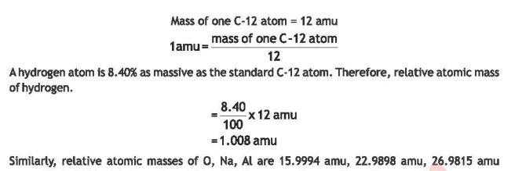

**Examples:**

Hydrogen: 1.008 amu.  Oxygen: 15.9994 am

**3.5. Isotopes**

*Isotopes are the atoms of an element whose nuclei have the same atomic number but different mass numbers. This is because atoms of an element can differ in the number of neutrons.*

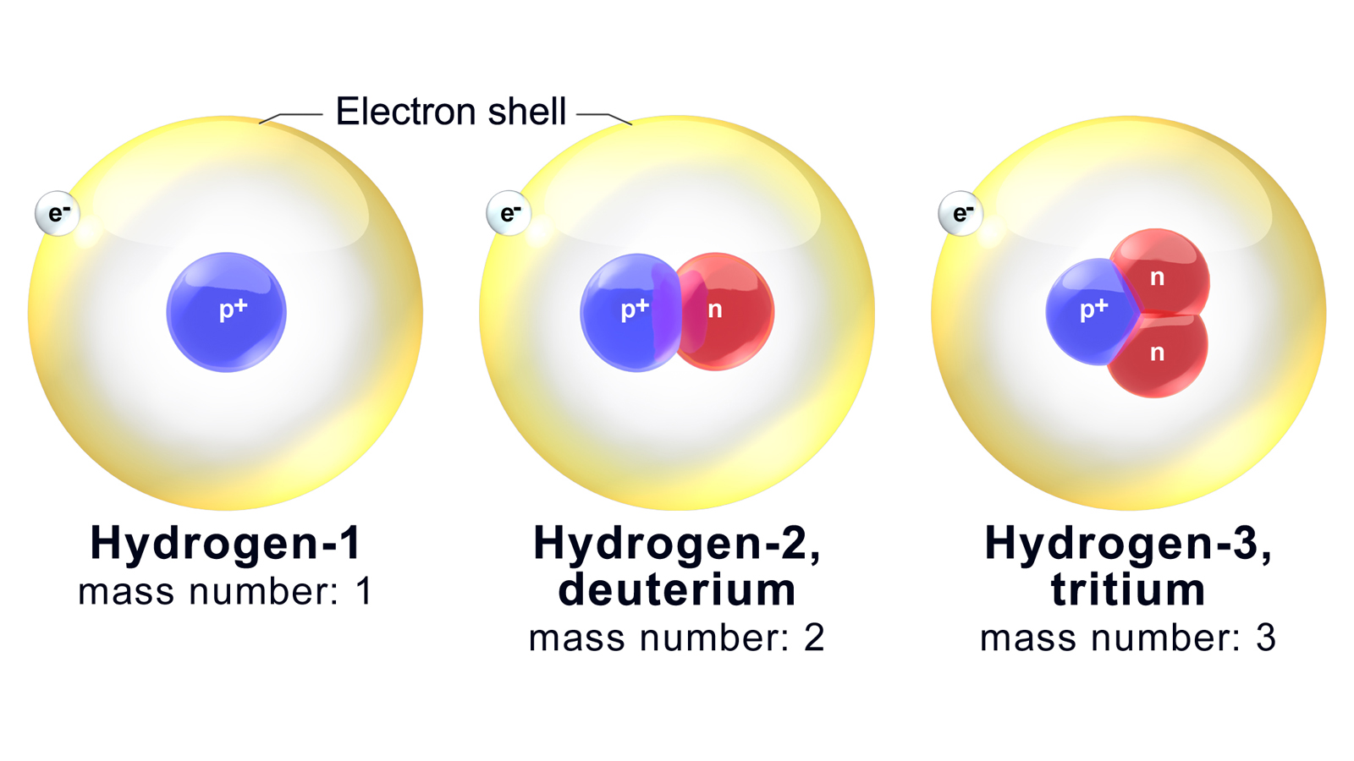

Atoms of the same element with the **same protons (Z)** but **different neutrons** (→ different mass numbers).

**Impact on Dalton’s Theory:**

Dalton assumed all atoms of an element are identical, but isotopes disproved this.

**Hydrogen Isotopes:**

| **Isotope** | **Protons** | **Neutrons** | **Symbol** | **Natural Abundance** |
| --- | --- | --- | --- | --- |
| Protium | 1 | 0 | ¹H | 99.99% |
| Deuterium | 1 | 1 | ²H | 0.0015% |
| Tritium | 1 | 2 | ³H | Rare (radioactive) |

**Carbon Isotopes:** ¹²C (98.8%, stable), ¹³C (1.1%), ¹⁴C (0.009%, used in carbon dating).

**Chlorine Isotopes:**  ³⁵Cl (75.77%), ³⁷Cl (24.23%).

**Uranium Isotopes:**  ²³⁴U (0.006%), ²³⁵U (0.72%, nuclear fuel), ²³⁸U (99.27%).

**Key Points:**

* **Same chemical properties** (same protons/electrons).
* **Different physical properties** (e.g., density, melting point).

**Calculating Relative Atomic Mass**

**Formula:**

The relative atomic mass of an element can be calculated from the relative masses of its isotopes and their relative abundance

**Calculate Relative Atomic Mass of Carbon**



**Uses of Isotopes**

| **Isotope** | **Application** |
| --- | --- |
| **¹⁴C** | Carbon dating (age of fossils). |
| **¹³¹I** | Diagnosing thyroid disorders. |
| **⁶⁰Co** | Cancer treatment (radiation therapy). |
| **²⁴Na** | Detecting blood flow obstructions. |

**Carbon Dating**

Carbon-14 is used to estimate the age of carbon-containing substances. Carbon atoms circulate between the oceans, and living organisms at a rate very much faster than they decay. As a result the concentration of C-14 in all living things keeps on increasing.

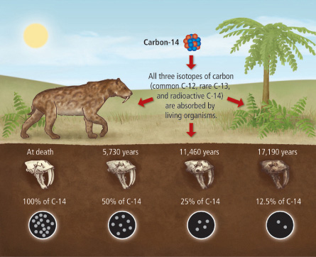

1. **Mechanism of chemical reactions** – *Isotopic labelling* (e.g., using deuterium or carbon-14) helps trace the path of atoms through a reaction, revealing reaction steps.
2. **Dating rocks, soils, mummies** – *Radioisotopes* like carbon-14 (for organic remains) and potassium-40 or uranium-238 (for rocks and minerals) are used in **radiometric dating** to estimate age.

**Cations & Anions**

**Cations (+ve ions):** Formed when atoms **lose electrons** (metals).

**Example:**

* Na → Na⁺ + e⁻ (loses 1 electron).
* Mg → Mg²⁺ + 2e⁻ (loses 2 electrons).

**Anions (-ve ions):** Formed when atoms **gain electrons** (non-metals).

**Example:**

* O + 2e⁻ → O²⁻ (gains 2 electrons).
* F + e⁻ → F⁻ (gains 1 electron).

**Key Rule:** Ions achieve **noble gas configuration** (stable octet).

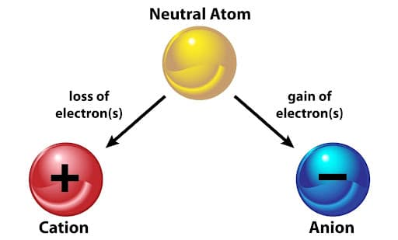

**Electronic Configuration**

***The arrangements of electrons in the shells and subshells are called the electronic configuration.***

***Shells (n):***

According to Bohr's atomic theory, the electron in an atom revolves around the nucleus in one of the circular paths called shells or orbits. Each shell has a fixed energy.

K (n=1), L (n=2), M (n=3), etc. → Higher **n** = higher energy.

**Subshells:**

A shell or energy level is sub divided into sub-shells or sub-energy levels. n value of a shell is placed before the symbol for a sub-shell.

| **Subshell** | **Max Electrons** |
| --- | --- |
| s | 2 |
| p | 6 |
| d | 10 |
| f | 14 |

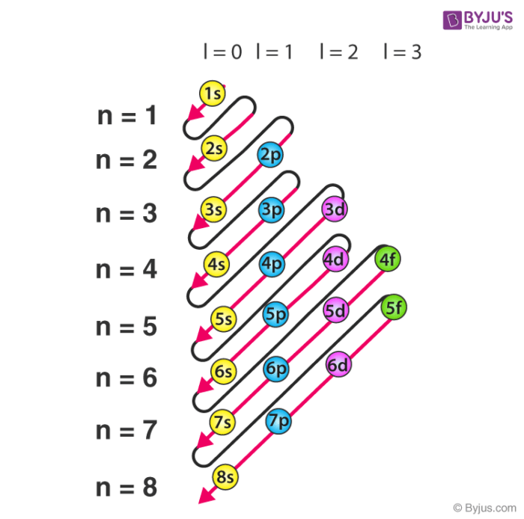

**Order of Filling (Aufbau Principle):**

The arrangement of electrons in sub-shells is called the electronic configuration. We can fill the electrons present in various elements by using the Auf Bau Principle. According to this principle, electrons fill the lowest energy sub-shell that is available first. This means electron will fill first 1s, then 2s, then 2p and so on.

1s → 2s → 2p → 3s → 3p → 4s → 3d → ...

The increasing order of energy of subshells (according to the **n + l rule**) is:

1s < 2s < 2p < 3s < 3p < 4s < 3d < 4p < 5s < 4d < 5p < 6s < 4f < 5d < 6p < 7s < 5f < 6d < 7p

**Example for Oxygen (Z=8):**

1s2, 2s2, 2p4

**Symbols for atoms and ions**

The symbol for an atom represents the element. It consists of one or two-letters, the mass number as a left superscript, the atomic number as a left subscript, and the charge as a right superscript. For example,

${{}_{12}^{24}Mg}_{}^{2+}$

This number is often omitted. This diagram shows a symbol for magnesium "Mg" which stands for magnesium. The number to the upper left of the symbol is the mass number, which is 24. The number to the upper right of the symbol is the charge which is positive 2. The number to the lower left of the symbol is the atomic number which is 12.

**Planck Constant (Additional Information)**

Planck's constant, denoted by the symbol 'h', is a fundamental constant in physics, specifically within quantum mechanics.

 It relates the energy of a photon to its frequency, and its value is approximately 6.626 x 10⁻³⁴ joule-seconds.

This constant quantifies the energy packets (quanta) exchanged in interactions between matter and radiation.

